**Phase III: Software Design and Modeling**

**Deadline: April 1st, 2024, 23:59**

**Software Design and Modeling**

**Group Name:** Online Bookstore

**Software Architecture**

***System Architecture***

The system architecture of the book ecommerce application encompasses various components that work together to provide a seamless user experience. Here's an overview of how different parts of the system collaborate:

* Frontend:

-The frontend layer is responsible for displaying the user interface to clients.

-It contains web sites for browsing books, searching for specific titles, checking book details, managing your shopping basket, and making purchases.

-Responsive design technologies include HTML, CSS, JavaScript, and Bootstrap.

* Backend:

-The backend layer handles the application's business logic and data processing.

-It is made up of a number of microservices that handle diverse functions.

-Technology: PHP for server-side scripting.

Microservices:

* Authentication Service

-Authentication Service manages user authentication and authorization.

-Provides endpoints for user login and registration.

-Provides secure access to protected resources.

* Catalog Service:

-Manages book catalog and associated data.

-Endpoints are provided for browsing books, searching by title, and retrieving book details.

* Order Service: Manages.

-Oversees order processing and fulfillment.

-Provides endpoints for adding products to the shopping cart and placing orders.

-Coordinates with the Catalog Service.

* Contact Form Service

-Contact Service manages user inquiries and messages via the contact form.

-Contact form submissions are saved in the database for future processing.

* Admin Dashboard Service

-The Admin Dashboard Service allows administrators to manage book listings via a separate interface.

-Administrators can update the bookstore catalog by adding new books, updating existing ones, and deleting items that are no longer relevant.

**Component Diagram:**

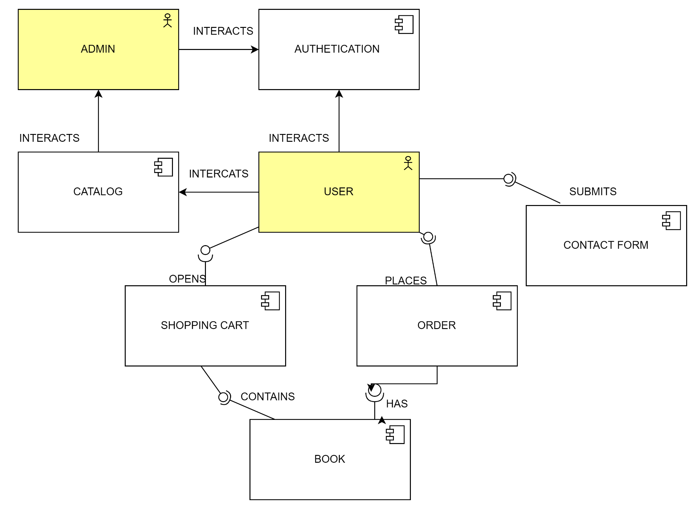

***Detailed Design***

**Class Diagram:**

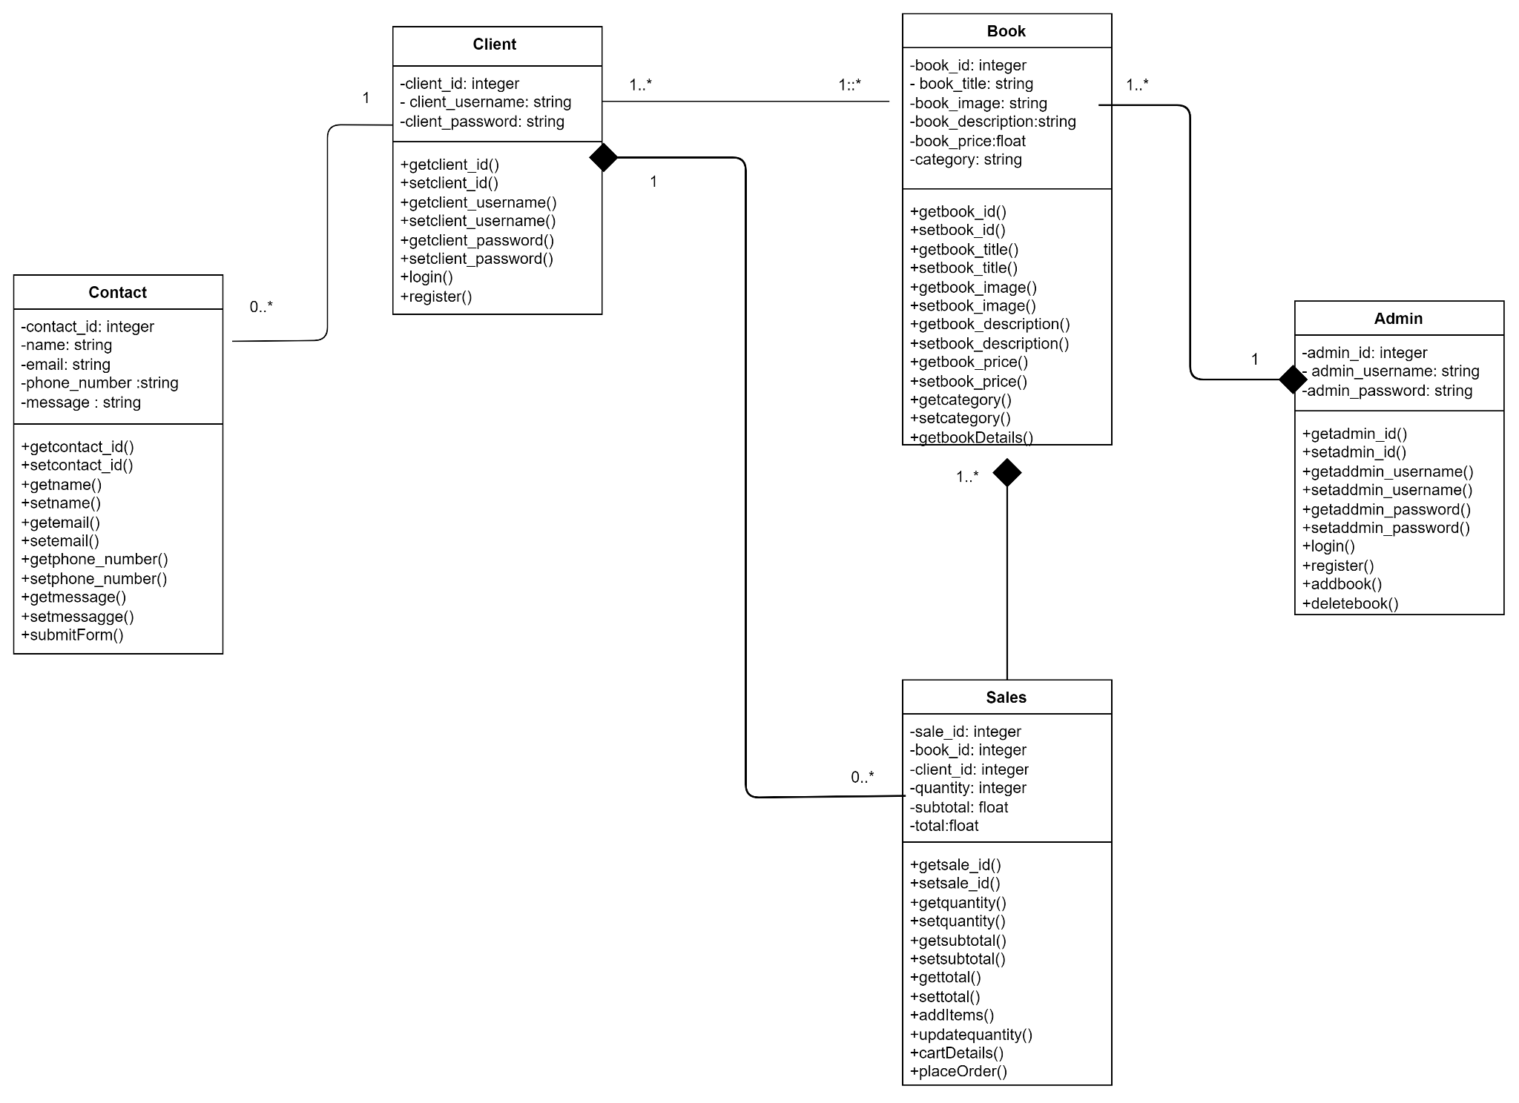

**Explantation:**

- User represents registered users of the application.

- Book represents individual books available in the bookstore.

- Sales represents an order placed by a user.

- Admin represents administrators who manages the bookstore.

- Contact represents the form used by users to contact the business.

**Sequence Diagrams:**

* Client Sequence Diagram

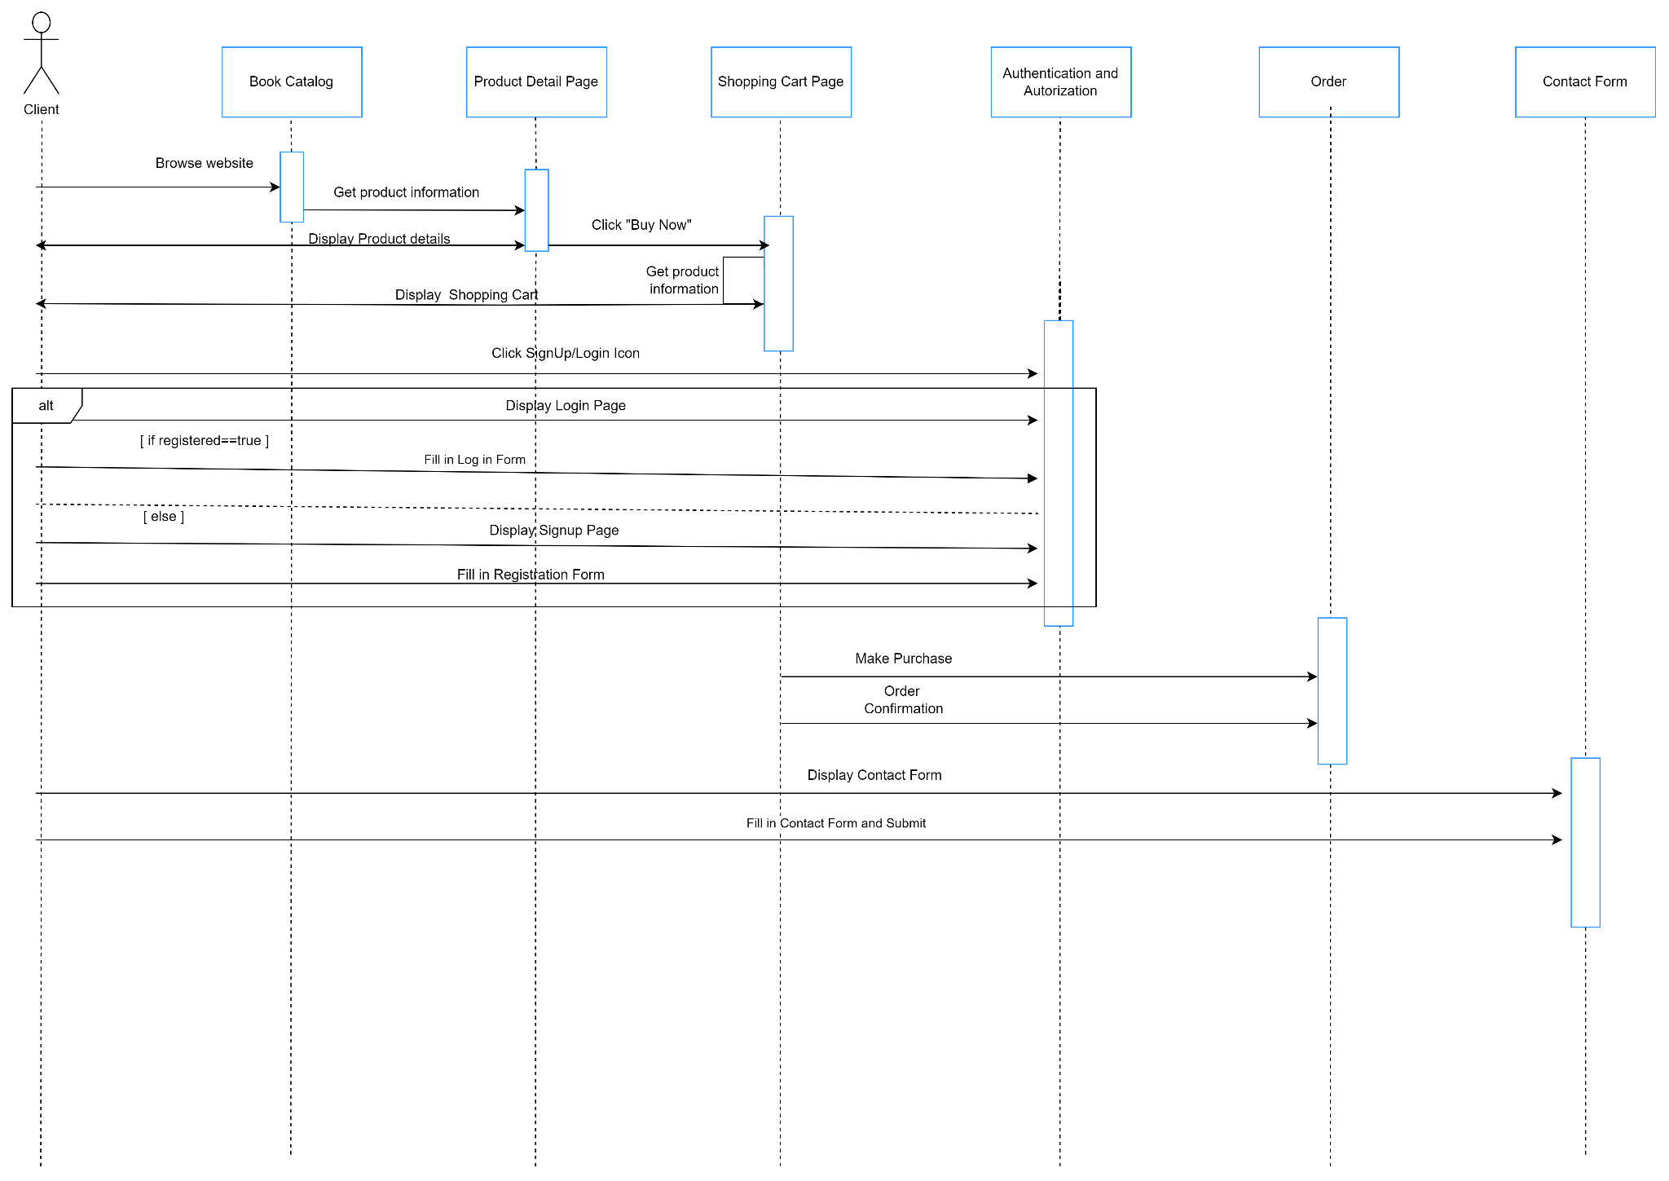

**Explanation:**

1. A request is sent to the Catalog Service to retrieve a list of available books.

2. Catalog Service sends the list of books for the user to see.

3.User selects a book and views the book detail page.

4. User selects a book and adds it to the shopping cart.

5. Order Service updates the shopping cart with the selected book.

6. User proceeds to checkout.

7.If user is logged in the order is completed if not is told to login or register first

8.User can submit a message by filling the contact form

9.A request is sent by the user to show the contact form page

9.User fills in the form and submits it

10.The message is sent

* Administrator Sequence Diagram:

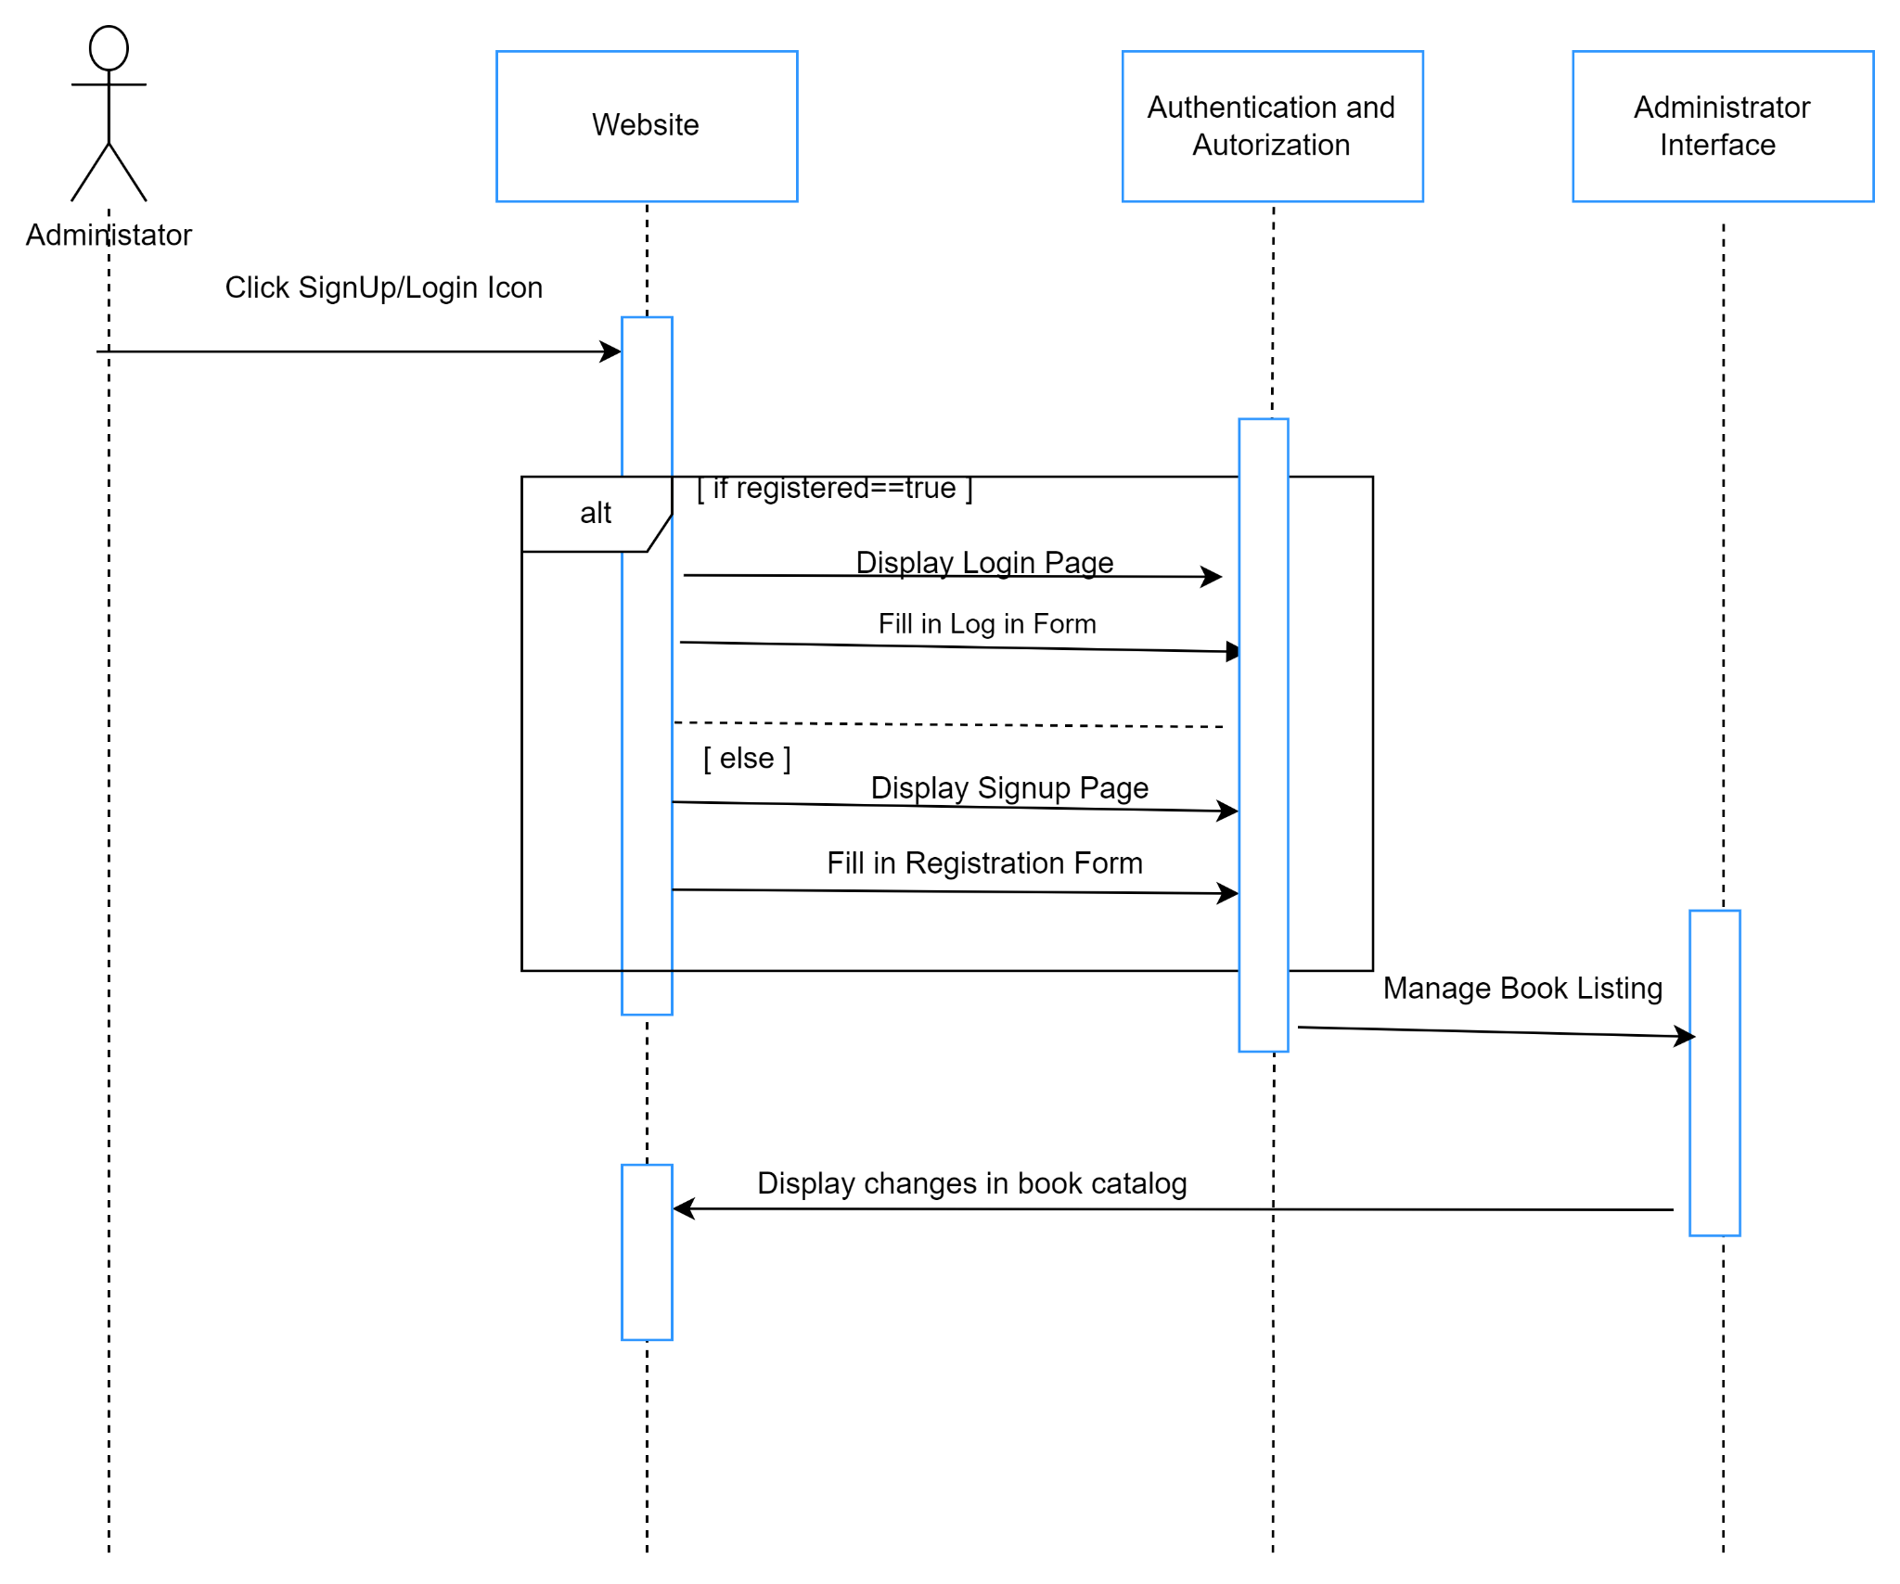

**Explanation:**

1.Administator makes a request to the UI to go to the login/registration page

2. If the admin is registered he/she fills in the log in form and it is redirected to the the admin dashboard

3.The admin manages the book listing

4. Changes made are reflected in the catalog service

* Database Design:

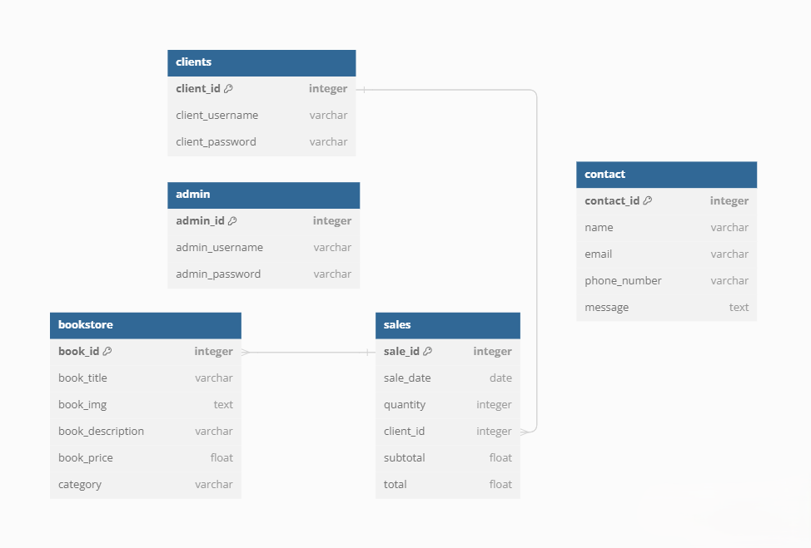**Tables in the Database:**

a. Clients Table: This table stores information about clients or users of the online bookstore. It includes fields such as client_id, client_username, and client_password.

b. Admin Table: This table stores information about administrators of the online bookstore. It includes fields such as admin_id, admin_username, and admin_password.

c. Contact Table: This table stores information about messages sent to the bookstore's contact form. It includes fields such as contact_id, name, email, phone number, and message.

d. Bookstore Table: This table stores information about books available in the online bookstore.It includes fields such as book_id, book_title, book_img, book_description, book_price, and category.

e. Sales Table: This table stores information about sales transactions made in the online bookstore. It includes fields such as sales_id, sale_date, quantity, client_id, subtotal, and total.

**Relationships Between Tables:**

a. Bookstore and Sales: There is a many-to-one relation between the Bookstore and Sales tables. This relationship is established by the book_id field in the Sales table, which refers to the book_id field in the Bookstore table. This enables numerous books to be connected with a single transaction.

b.Clients and Sales : There is a one-to-many relationship between the Clients and the Sales tables.The relationship between these tables is established by the client_id field in the Sales table, which refers to the primary key client_id in the Clients Table.These enables one Client to have multiple transactions.

**Efficient Organization of Data:**

a. Primary Keys: Each table has a primary key (e.g., client_id, admin_id, contact_id, book_id, sales_id) that is unique to each record in the table. Primary keys protect data integrity and allow for more efficient record retrieval.

b. Foreign Keys: The Sales table has foreign keys (book_id), (client_id), which relate to the primary keys (book_id) in the Bookstore database and the primary key (client_id) in the Clients table. This creates a relationship between the tables and maintains referential integrity.

c. Normalization: The normalization principles, which call for arranging data to reduce repetition and dependency, are followed in the database architecture. Every table has fields that are relevant to the particular entity it represents (e.g., sales, books, administrators, clients), and table relationships are established by logical associations between entities.

d. Optimized Data Types:Data types and sizes were carefully chosen to maximize storage efficiency and query performance. Numeric fields, such as prices and quantities, may utilize appropriate numeric data types (e.g., INTEGER, FLOAT), whereas textual fields, such as usernames and passwords, use VARCHAR or TEXT data types with appropriate lengths.

***Modeling***

**Use Case Diagram**:

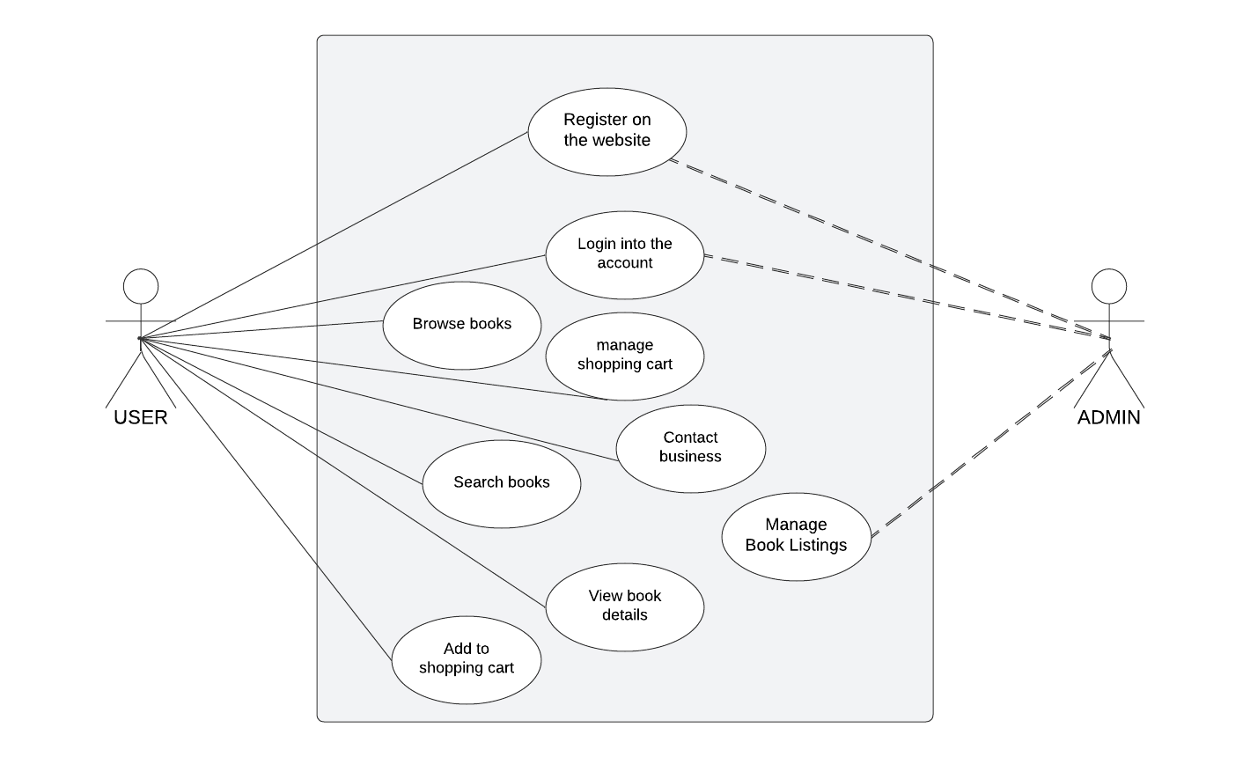

* **Actors**:

Primary Actor (User): This is the main actor interacting with the online bookshop system. The user takes a variety of activities to browse, search, and manage books, as well as engage with the business via the contact form.

Secondary Actor (Admin): Represents the administrator or staff member in charge of managing book listings in the online bookshop system.

* **Use Cases:**

**1**.User Registration:

Description: Allows users to establish new accounts on the bookstore's website.

Steps: The user enters the required information (e.g., username, password) and submits the registration form.

**2.**User Login:

Description: Logs a registered user into their account.

Steps: The user enters their username and password and submits the login form.

**3.**Browse books:

Description: Allows users to browse available books in the bookstore.

**4.**Search Books:

Description: Users can search for books by title.

Steps: User enters book title in the search bar and the book is displayed

**5**.View Book Details:

Description: Allows visitors to get extensive information on a single book.The user can view extensive information about the selected book, including its title, author, description, and price.

Steps: User clicks on the “Shop Product” button to view detailed information about the selected book

**6**.Add to the Shopping Cart:

Description: Users can add selected books to their shopping basket for purchase.

Steps: User clicks on “Add to Cart” button for the book to be added to the shopping cart

**7**.Manage Shopping Cart:

Description:Users can add or update products in their shopping cart.

Steps: Users can select multiple books, view their total and proceed to checkout.

**8.**Contact Business:

Description: Allows users to contact the bookstore using a contact form.

Steps: Users can fill in the contact form and submit it.

**9.**Manage Book Listings:

Description: Administrators can add new books and remove outdated ones.Admin can add, update, and remove book listings as needed.

Steps:Administrator can select on a a specific book for it to be delete or click on the “Add Book” button to add a new book to the catalog.

**Activity Diagrams:**

* Activity Diagram: Order Book Process

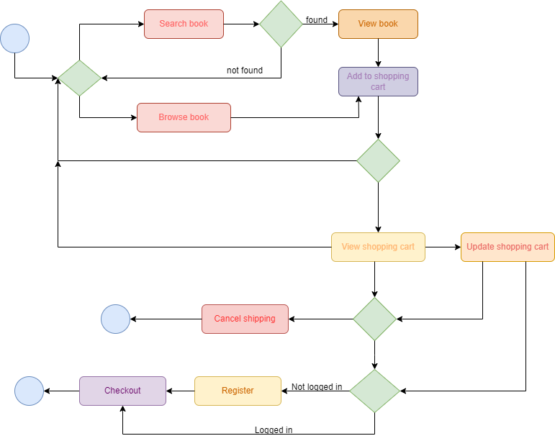

***Process explanation:***

1)User searches for a specific book

2)User also can browse for books

2)If book searched is found user views the book

3)User adds the book to the shopping cart

4)Views the shopping cart and makes updates if needed

5)Cancel shipping or proceed with the order

6)To proceed with the order user has to log in

7)If the user is not logged in, has to register

8)Proceed with the checkout

* Activity Diagram: User Registration and User LogIn

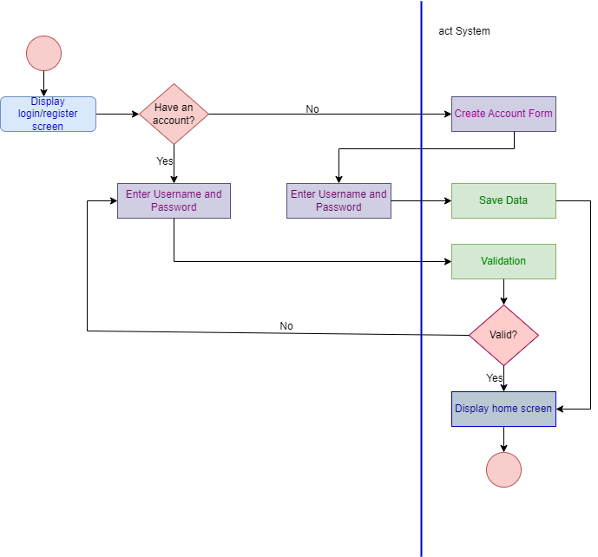

***Process explanation:***

1)Display the login/register screen

2)If you have an account proceed with the login form.

3)If it’s valid display the home screen

4)If you don’t have an account then create an account

5)Enter the data needed

6)Validate the account

7)If it’s valid ,display home screen

* Activity Diagram: Browse books

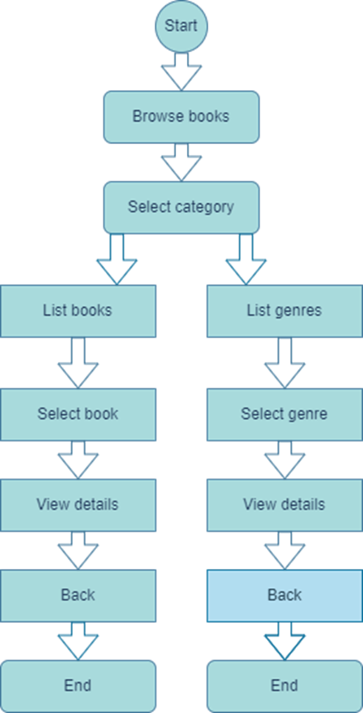

***Process explanation:***

1)User starts browsing for books

2)Selects a category

3)Lists each category

4)Selects the category needed

5)View more details about the category

6)Return back to main menu

* Activity diagram: Search books

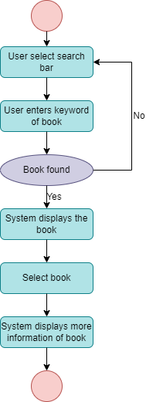

***Process explanation:***

1)User selects search bar

2)Enters keyword of the book

3)If the book is not found returns again to the search bar,if it is found system displays the book

4)Selects the book

5)System displays more information of the book

* Activity diagram:Contact form

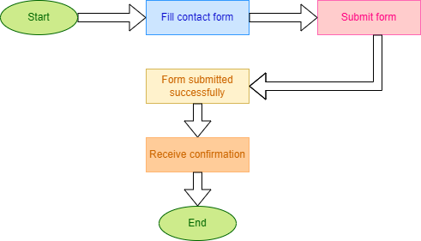

***Process explanation***:

1)User fills the contact form with their credentials

2)Submits the form

3)If the form is submitted successfully then receive confirmation

* Activity Diagram:Admin Manage Books

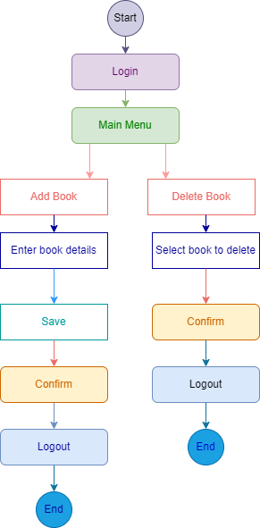

***Process explanation:***

*Add book:*

1)Admin logs in

2)Display the Main Menu

3)Admin proceeds to add the book

4)Enters the book details

5)Saves the new book

5)Confirms the changes

6)Logout

*Delete book:*

1)Admin logs in

2)Display the Main Menu

3)Admin proceeds to delete the book

4)Selects book to delete

5)Confirm the changes

6)Logout

**State Diagrams:**

* State diagram:Shopping cart

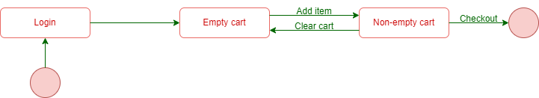

***Process explanation:***

1)When the user is logged in the cart is empty

2)User adds items to the shopping card

3)When the cart is non empty user can remove items from the cart

4)Proceeds with the checkout

* State diagram:Order



***Process explanation:***

1)User places the order

2)The order is created

4)User proceeds with the payment

5)Payment confirmation

6)Order is shipped

* State diagram:Login

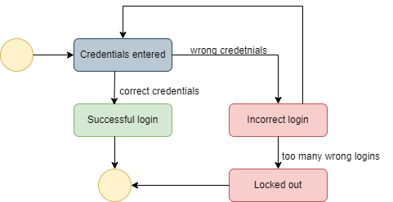

***Process explanation:***

1)User enters their credentials

2)If the credentials are entered wrong,it is a incorrect login

3)If there are so many attempts,user lockes out

4)If the credentials are entered correctly,it is a successful login

* State diagram:Register

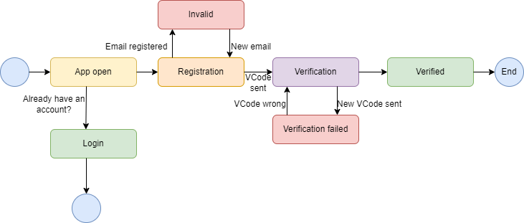

***Process explanation:***

1)User opens app

2)If already has an account ,login

3)If user doesn’t have an account,has to register

4)If the email is used once,user should enter another email

5)System sends a verification code,if the code is entered wrong verification fails

6)If the verification code is entered correctly ,user is verified